1. Creating a directory in hdfs file system from linux



1. Try listing the folder/directory structure in hdfs

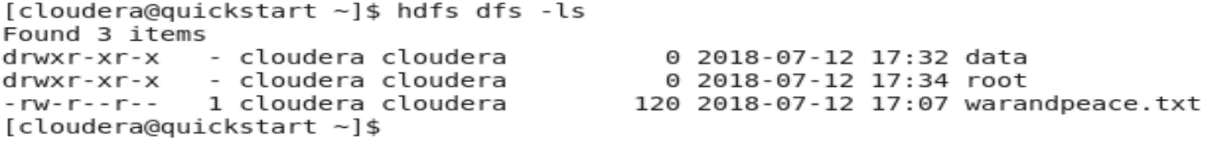

1. You can also see the new directory through the browser by going through the file system (namenode -> utilities -> Browser file system)

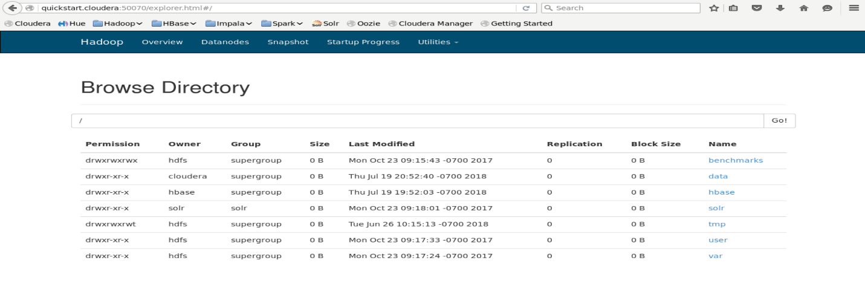

1. Try creating a subdirectory under the directory that was created in the previous step



1. View the contents of the folder that was created initially (data folder). You can see the new folder created under it (books folder).



1. Or view it in the browser

